Table of Contents
1 Safety Information 1
1.1 UPS safety information 1
1.2 Battery safety information 1
2 Product Overview 3
2.1 Specifications 3
2.2 Front panel features 5
2.3 Rear panel features 5
3 Installation 7
3.1 Unpacking inspection 7
3.2 Installation information 7
3.3 Installation and output connection 8
3.4 Standard Model Built-in Battery Pack Installation Guide 8
4 Network Functions 10
4.1 Communication port 10
4.2 EPO port（optional） 10
4.3 Intelligent card (optional) 11
5 Operation 12
5.1 Button operation 12
5.2 Display interface 12
5.3 UPS On/Off operation 14
5.4 UPS Settings 15
5.5 Parameters inquiring operation 16
5.6 Operation mode 17
6 Fault Messages 20
7 Troubleshooting 24
8 Software Download & Installation 26

Safety Information

UPS safety information
- Read all safety information and operating instructions carefully before attempting to install, service or maintain the UPS. Save this manual properly for reuse.
- This UPS is intended for indoor use only.
- Do not operate this UPS in direct sunlight, in contact with fluids, or where there is excessive dust or humidity.
- Be sure the air vents on the UPS are not blocked. Allow adequate space against the wall for proper ventilation.
- Do not open the UPS case as you will, there is a high risk of electric shocks inside.
All connection/wiring/servicing must be performed by a qualified electrician.
- Do not connect to the equipment like hair dryer or electric heater.
- Do not use liquid extinguisher if there is a fire, a dry powder extinguisher is recommended.
CAUTION
UPS has high voltage inside, do not repair it by yourself. If any questions, please contact local service center or dealer.

Battery safety information
- Environmental factors impact battery life. Elevated ambient temperatures, poor quality utility power, and frequent short duration discharges will shorten battery life. Replacing battery periodically can help to keep UPS in normal state and assure backup time required.
- Battery installing or replacing should be performed by a qualified electrician. If you want to replace the battery cable, please purchase it from our local service center or distributors to avoid fever and lighter which can cause fire by inadequate power capacity.
- Batteries may cause electric shocks and have a high short circuit current, follow below requirements before installing or replacing the batteries.
- Remove wristwatches, rings, jewelry and other conductive materials.
- Only use tools with insulated grips and handles.
- Wear insulated shoes and gloves.
- Do not put the metal tools or parts on the batteries.
- Before disconnecting the terminals from the batteries, cut off all the loads
to the batteries first.
- Do not dispose of the batteries with fire. The batteries may explode.
- Do not open or mutilate batteries. Released electrolyte inside is harmful to the skin and eyes, and maybe toxic.
- Do not connect the positive pole and negative pole directly, otherwise it will cause electric shocks or will be on fire.
- The battery circuit is not isolated from the input voltage, high voltage may occur between the battery terminals and ground, check if there is no voltage there before touching.
Note：Symbol instructions:
Symbol | Significations | Symbol | Significations
 | Caution |  | Protective earth
 | Danger! High Voltage! |  | Disable/mute audible alarm
 | Turn on |  | Overload
 | Turn off |  | Battery inspection
 | Standby or Shutdown |  | Repeat
 | AC |  | Display screen repeat key
 | DC |  | Battery

Product Overview

Specifications
Model |  | 1kVASRT | 2kVASRT | 3kVASRT
Rated Capacity |  | 1 kVA / 900W | 2 kVA / 1800W | 3 kVA / 2700W
Input
Rated input voltage |  | 110 Vac / 115 Vac / 120 Vac / 127Vac
Rated input frequency |  | 50 Hz / 60 Hz (auto-sense)
Input voltage range |  | 50 ~ 80Vac (power derating linearly between 50% and 100% load);  80 ~ 150Vac (no derating);
Input frequency range |  | 40~70 Hz
PFC |  | ≥ 0.99
THDI |  | ≤ 6%
Bypass voltage range |  | -25% ~ +15% (settable)
Output
Output voltage |  | 110 Vac / 115 Vac / 120 Vac / 127 Vac(settable)
Voltage accuracy |  | ± 1%
Output PF |  | 0.9
Inverter overload capability |  | 108% ~ 127% load: transfer to bypass in 1 min;  127% ~ 150% load: transfer to bypass in 30 s;  > 150% load: transfer to bypass in 100 ms
From mains mode to BAT mode |  | 0ms (transfer time)
From mains mode to bypass |  | 4 ms (typical)
Output frequency | Line mode | Same as input frequency
Output frequency | BAT mode | (50 / 60 ± 0.1) Hz
Total voltage harmonic distortion |  | ≤ 2% (linear load); ≤ 5% (non-linear load)
Batteries
Battery type |  | Sealed lead acid maintenance free battery
DC voltage |  | 24 V | 48 V | 72 V
Inbuilt battery |  | 12 V / 9 Ah | 12 V / 9 Ah | 12 V / 9 Ah
Quantity |  | 2 | 4 | 6
Charger output voltage |  | 27.1  ± 0.4 | 54.2  ± 0.8 | 81.3  ± 1.2
Recharging time |  | Standard model: 90% capacity restored in 3 hours;  Long time model: depend on the capacity of battery
Charging current (Max.) |  | Standard model: 1 A
System Control and Communications
Protections |  | Over-temp protection; Fan testing protection; Overload protection;  Output short circuit protection; Battery discharge protection
Communication port |  | Standard: RS232; Options: USB, SNMP card, dry contacts
Display |  | LCD+LED
Environmental
Operatinghumidity |  | 0 ~ 95 % RH @ 0 ~ 40°C (non-condensing)
Storage temperature |  | -25°C ~ 55°C(exclude batteries)
Operating altitude |  | ≤ 1000m, above 1000m, derate 1% for each rising 100m
Protection class |  | IP20
Noise level |  | ≤50dB (at 1m)
Others
Dimensions (mm)  W × D × H |  | 440×316×88 | 440×468×88 | 440×560×88
Cross Weight (kg) |  | 11.5 | 19.8 | 27.0
* Derate capacity to 70% in CUCF mode.
Note：
Model | Type
1kVASRT | 1 kVA Standard model
2kVASRT | 2 kVA Standard model
3kVASRT | 3 kVA Standard model

  - Front panel features

Rear panel features

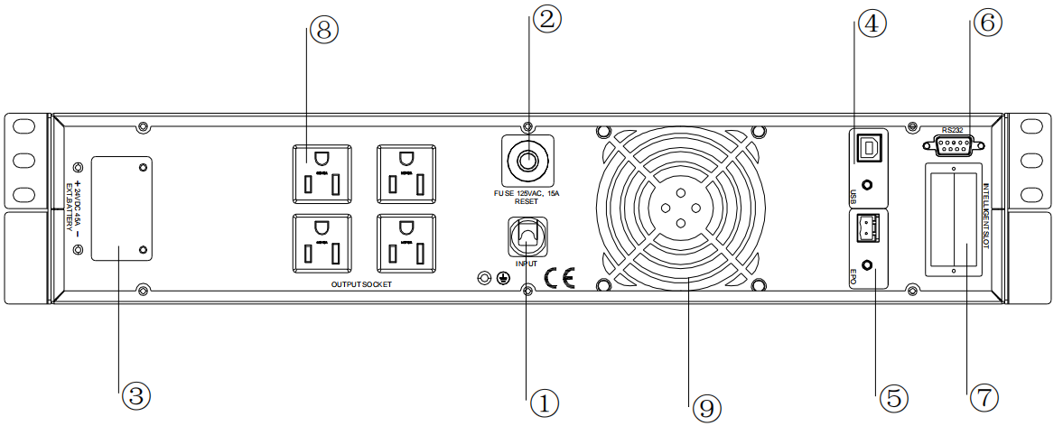
- 1kVASRT(DC24V)rear panel

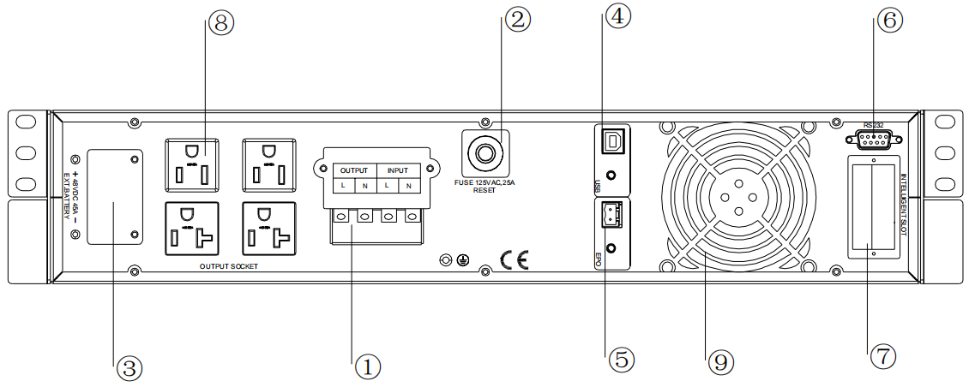

- 2kVASRT (DC48V)rear panel
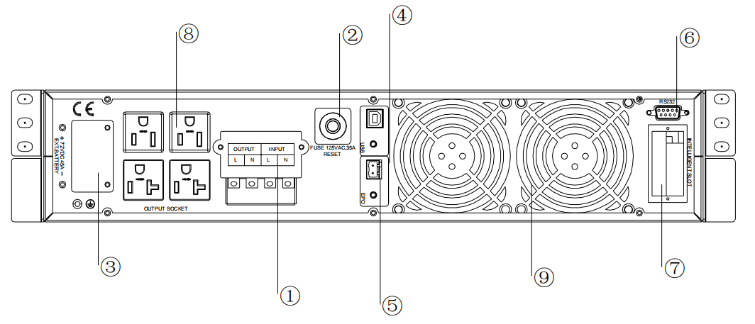
- 3kVASRT (DC72V) rear panel

①AC input socket | ⑥RS232
②Overcurrent protection | ⑦Intelligent slot
③Battery connect(Optional) | ⑧Output sockets
④USB(Optional) | ⑨Fan
⑤EPO(Optional)
Note:
The figure is for reference only. Due to the technology upgrading and development, the real unit might be different from the figure.

Installation

Unpacking inspection
- Open the UPS package and inspect the contents upon receipt. The accessories attached to the UPS contain a power cord, a user manual, communication cable, CD-ROM. The long backup model also includes the cable for connection to battery bank.
- Check if the unit is damaged during transport. Do not power on and notify the carrier and dealer if find damaged or parts missing.
- Verify this unit is the model you want to buy. Check the model name showed both on the front panel and rear panel.
Note:
Keep the packaging box and packaging materials for future transport use. The equipment is heavy. Always handleit with care.

Installation information
- The UPS installation environment must be in good ventilation, away from water, flammable gases and corrosive entities.
- Do not lie down the UPS against the wall so that front and side panel air intake hole, rear panel air outtake hole will be unobstructed.
- The ambient temperature around the UPS should be within 0℃~40℃（non-condensing）.
- If dismantling the machine at low temperatures, there may be condensation droplets, users can not install or operate it before UPS completely got dry both inside and outside, otherwise there will be danger of electric shocks.
- Place the UPS near the mains source so that can cut off utility power without any delay in case of emergency.
- Make sure the load connected to the UPS is off when users connect it to UPS, and then turn on the load one by one later.
- Connect the UPS with the power outlet which is over-current protected. Do not connect the UPS with power outlets whose rated current is less than the maximum input current of this UPS.
- All power outlets should be configured with earthing device for safety.
- UPS could be electrified or powered no matter the input power cord is tied or not, even when the UPS is off.The only way to cut off the output is switching off the UPS and disconnecting the mains power supply.
- For all standard model UPS, it is advised to charge the batteries over 8 hours before using. Once the AC mains power energizes the UPS, it will automatically charge the batteries. Without prior charging, UPS output remains as usual but with shorter back-up time than normal.
- When connected to motor, display equipment, laser printer etc., UPS power selection should be based on the startup power of the load which is usually twice as rated power.
- Wiring by a qualified electrician is required. Ensure input cables and output cables are connected correctly and firmly.
- If install a leakage current protective switch, please install it on output cable.

Installation and output connection
Normally, output connection of 1~3kVA series is configured with power outlets or terminal blocks, users can plug the load cable into the UPS power outlets to energize the load. Make sure the mains cable and breakers in the building are enough for the rated capacity of UPS to avoid the hazards of electric shock or fire.

Standard Model Built-in Battery Pack Installation Guide
Step 1 Make sure the UPS is in mains mode, remove the two plastic panels on the front.
Step 2 Remove the two baffles in the picture below with a screwdriver.
Step 3 Separate the battery terminals, pull the plastic handle of the battery pack, and drag the battery pack out.
Note: The battery pack is heavy. Please pay attention to safety when taking the battery pack to prevent foot injury.
Step 4 After replacing the battery, put the battery pack back into the UPS. After connecting the battery terminals, lock the two baffles and cover the plastic panel.

Network Functions

Communication port
Users could monitor the UPS system through the communication port such as standard RS232 port and USB port with computer. Connecting this UPS with computer by communication cable could achieve UPS management easily.
>RS232 port：
Pins | 1 | 2 | 3 | 4 | 5 | 6 | 7 | 8 | 9
Indication | empty | send | receive | empty | ground | empty | empty | empty | empty
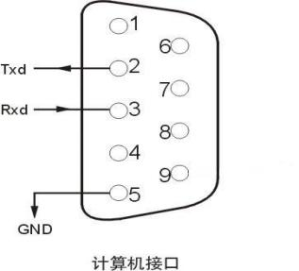
Note:
RS232 interface is set as below:
- Bit rate: 2400 bps
- Byte: 8bit
- Completion code: 1 bit
- Bit pattern: None
>USB port：
Pins | 1 | 2 | 3 | 4
Indication | +5V | date+ | date- | GND

EPO port（optional）
EPO is the short for Emergency Power Off. EPO port is on the rear panel of the UPS. It’s green. Users can cut off the output of UPS immediately by operating EPO port in case of emergency.

Normally, pin1 and pin2 are connected so that the machine can be working normally. When some emergencies happen, and when users have to cut off the output, just need to disconnect the connection between pin1 and pin2, or just pulling it out.

Intelligent card (optional)
There is an intelligent slot on the rear panel of the UPS, it’s for SNMP card and dry contacts. Users can insert any type intelligent card from those three into it to monitor and manage the UPS. And users don’t have to turn off the UPS when install the intelligent card. Follow below process:
- First of all, remove the intelligent slot cover;
- Then insert the intelligent card (SNMP card and dry contacts);
- Finally, screw the intelligent card back.
> SNMP card (optional)
SNMP card on UPS is compatible with the most software, hardware and network operating system, it is a network management of UPS, with this function, UPS can login on internet , which can supply information of UPS status and input power, and even possible to control UPS via net management system.
> Dry contacts card (optional)
Insert the dry contacts card into the intelligent slot. It’s another type function of intelligent monitoring.
Position | Definition
PIN1 | ON：UPS is malfunctioning
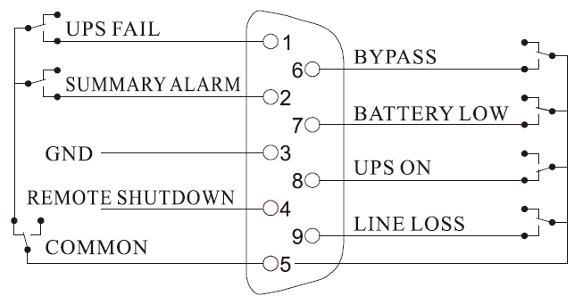  PIN2 | ON：Alarm（system failure）
PIN3 | Ground
PIN4 | Remote shutdown
PIN5 | Common
PIN6 | ON：Bypass mode
PIN7 | ON：Battery low
PIN8 | ON：Inverter mode；  OFF：Bypass mode
PIN9 | ON：No AC power in

Operation

Button operation
Button | Function
“ON” key  (+) | Press the two keys for more than half a second to turn on the UPS.
“OFF” key  (+) | Press the two keys for more than half a second to turn off the UPS.
TEST/MUTE key  (+) | Press the two keys for more than 1 second in Line mode or ECO mode or CUCF mode: UPS runs the self-test function.  Press the two keys for more than 1 second in battery mode: UPS runs the mute function.
INQUIRING key  (,) | Not in setting mode:  - Press or for more than half a second (less than 2 seconds): display the items orderly.  - Press for more than 2 seconds: Circularly and orderly display the items every 2 seconds, when press the key for some time again, it will turn to output status.  In setting mode:  - Press or for more than half a second (less than 2 seconds): Select the setting option.
FUNCTION SETTINGSkey  () | Not in setting mode:  - Press the key for more than 2 seconds: Function settings interface.  In setting mode:  - Press the key for more than half a second (less than 2 seconds): go to the function setting options.  - Press the key for more than 2 seconds: exit from this function settings interface.

Display interface
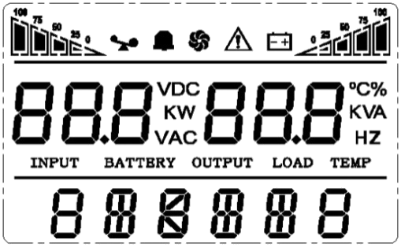
Icon display

UPS status information

Operation mode

Display | Function
Icon display
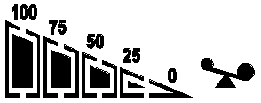 | Load icon:The approximate load capacity percentage (0-25%, 26-50%, 51-75%and 76-100%) is indicated by the number of load bar sections illuminated.When UPS is overloaded, the load iconwill flash.
 | Mute icon: Indicates the audible alarm is disabled / mute.  Press the mute key in the battery mode, themute icon flash.
 | Fan icon:Indicates fan working status. When the fan normally runs, the icon displays rotation; if the fan is not connected or faulty, the icon will flash.
 | Fault icon:Indicates UPS is in fault mode.
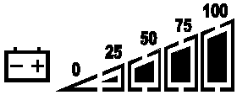 | Battery status icon: Indicates the battery capacity of 0-25%, 26-50%, 51-75%, and 76-100%. When the capacity of battery get low or battery disconnected, the batterystatus iconwill flash.
UPS status information
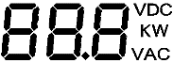 | - In non-setting mode, it displays UPS output information when UPS normally runs; Fault code will be told in fault mode.  - In setting mode, users could adjust different output voltage, activate ECO mode, activate CUCF mode, select an ID number and so on by operating function setting keys and inquiring key.
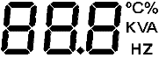
Operation mode
 | Indicates the power capacity of UPS within 20 secondsafter starting up.  IndicatesUPS operation mode in 20 seconds,such as STDBY (standby mode), BYPASS (Bypass mode), LINE (AC mode), BAT (Battery mode), BATT (Battery Self Test mode), ECO (Economic mode), SHUTDN (Shutdownmode), CUCF (Constant Voltage and Constant Frequency mode).
LED indicator light functions
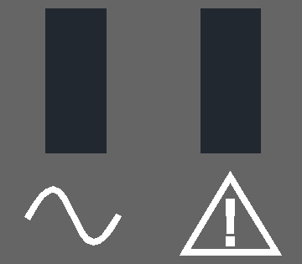 | They are respectively inverter light and fault light from left to right.  The inverter light (green LED indicator light) illuminates continuously: it indicates that UPS is in mains mode or ECO mode or power supply status in battery mode.  The fault light (red LED indicator light) illuminates continuously: it indicates that UPS is in fault status.  Note: For LED indication in different modes, please refer to LED/display panel and alarm list.

UPS On/Off operation
Operation | Description
Turn on the UPS | > Turn on the UPS with mains power  - With mains power connected, UPS works in bypass mode, its output is same as the input voltage within the input range. If there is no need of output voltage when mains power connected, you can set up bPS to ‘OFF’. Default bPS is ON, it means there is bypass output when power on.  - Press the ON key for more than half a second to start the UPS, then it will start the inverter.  - Once started, the UPS will perform a self-test function. When the self-test finishes, it will turn to online mode.  > Turn on the UPS by battery without mains power  - When main power is disconnected, press the ON key for more than half a second to start UPS.  - The operation of UPS startup process is almost same as above process with mains power. After the self-test finishes, UPS will work in battery mode.
Turn off the UPS | > Turn off the UPS in Line mode  - Press the OFF key for more than half a second to turn off the UPS.  - After UPS shutdown, there is no output. If output is needed, you can set BPS ‘ON’ on LCD setting menu.  > Turn off the UPS in battery mode without mains power  - Press the OFF key for more than half a second to turn off the UPS.  When UPS shutdown, it will do self-test first, until there is no display on the panel.
UPS self-test/mute test operation | - When UPS is in LINE Mode, press the self-test/mute key for more than 1 second. UPS gets to self-test mode and tests its status. It will exit automatically after finishing test.  - When UPS is in BAT Mode, press the self-test/mute key for more than 1 second, the buzzer stops beeping. If you press the self-test/mute key for one more second, it will restart to beep again.
UPS Setting | - Enter Setup interface. Press and hold the function setting keyfor more than 2 seconds, then come to Setup interface, press and hold the inquiring key (,) for more than half a second(less than 2 seconds), select the function setting, choose the setup interface, at the moment, the letters flash.  - Enter thesetup interface. Press and hold the function setting key for more than half a second(less than 2 seconds), then come to the setup interface, at this time, the letters doesn’tflash any more,the numerical value flash. Press and hold the inquiring key (,) for more than half a second (less than 2 seconds), select the numerical value in accordance with the function.  - Confirm the setup interface. After selecting numerical value, press and hold the function settingfor more than half a second (less than 2 seconds). Now, the setting function is completed and the numerical value illuminateswithout flashing.  - Exit from the setup interface. Press and hold function setting keyfor more than half a second (less than 2 seconds), exit from the setup interface and return to the main interface.  Note:  - UPS could not be set until it is connected to the battery and it is turned off and switched to Stdby mode (standby mode).  - Disconnect mains power after setting.  - The LCD display screen will automatically extinguish in about 1 min, and the setting will be configured normally.

UPS Settings
- Output voltage setting
LCD display | Settings
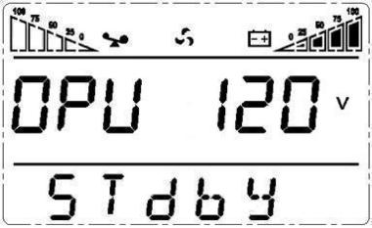 | For 110/115/120/127 VAC models, you may choose the following output voltage:  110: output voltage is 110Vac  115: output voltage is 115Vac  120 (default): output voltage is 120Vac  127: output voltage is 127Vac
- Low voltage of battery setting
LCD display | Settings
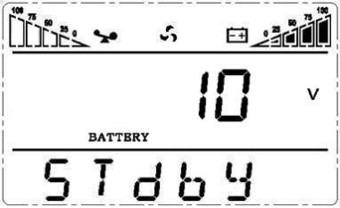 | The battery voltage selecting interface. You may choose the following output voltage:  9.8: Low voltage of battery is 9.8Vdc  9.9: Low voltage of battery is 9.9Vdc  10: Low voltage of battery is 10Vdc  10.2: Low voltage of battery is 10.2Vdc  10.5: Low voltage of battery is 10.5Vdc  dEF(default):EOD voltage automatically varies with loads, including 20 hours discharge protection

- Bypass mode setting
LCD display | Settings
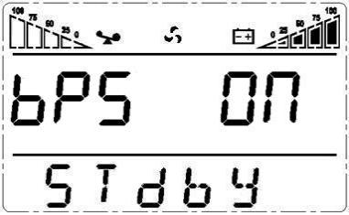 | Enable or disable Bypass function. You may choose the following two options:  ON: Bypass enable  OFF (default): Bypass disable
- AUO setting
LCD display | Setting
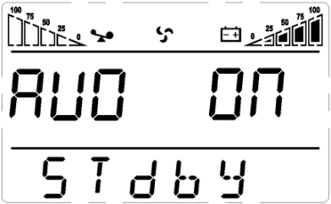 | AUO setting only can be set in Stdby mode or Bypass mode. You may choose the following two options:  ON: UPS will start up automatically and works in Line mode when connect mains.  OFF (Default): UPS won’t start up automatically when connect mains except EOD,it will work in standby or bypass mode.

Parameters inquiring operation
Press the inquiring keyorfor more than half a second (less than 2 seconds) to inquire about items. The inquired items include Input, Battery, Output, Load and Temperature. The displayed items on LCD screen are shown as following:
LCD display | Description
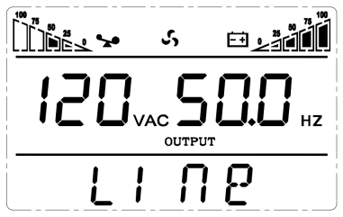 | Output：Display the output voltage and output frequency of the UPS. As the following graphic shows, the output voltage is 120V, the output frequency is 50Hz.
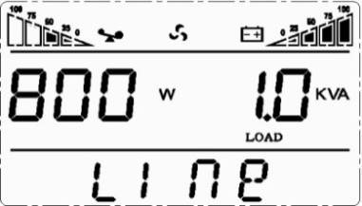 | Load: Display the numerical value of the active power (WATT) and apparent power (VA) of the load. For example, as the following graphics shows, the WATT of the load is 800W, VA is 1.0kVA (when disconnect loads, it is a normal phenomenon to show a small numerical value of WATT and VA).
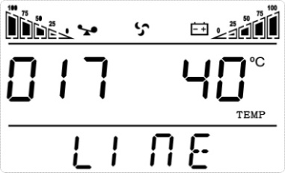 | Version and Temperature: Indicate firmware version ofUPSanddisplay the highest temperature of UPS components; As the following graphics shows, the firmware version is v1.7, the maximum temperature is 40℃.
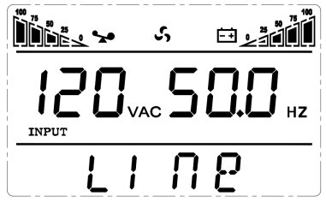 | Input: Display the voltage and frequency of the input. As the following graphics shows, the input voltage is 120V, input frequency is 50Hz.
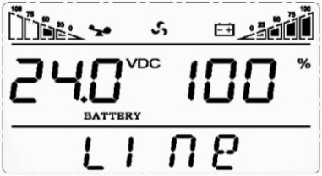 | Battery: Display the voltage and capacity of the battery. As the following graphics shows, the battery voltage is 24V, the capacity of battery is 100% (the capacity of battery is approximately reckoned according to the battery voltage).
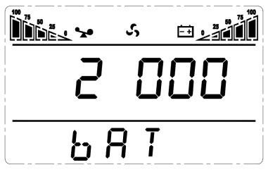 | Warning: Display the warning code.

Operation mode
Operation mode and LCD display | Description
Bypass mode  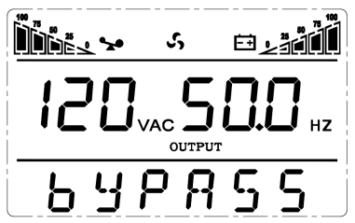 | Turn to bypass mode under the following three conditions:  - Connect mains power and the bypass setup is ON.  - Turn off the UPS in line mode and the bypass setup is ON.  - Overload in line mode.  Note: When UPS is working in bypass mode, it has no back up function.
Line mode | Being in line mode are as following: When input mains corresponding to the working conditions, UPS will work in line mode, LCD displays ‘Line’.
Stdby mode  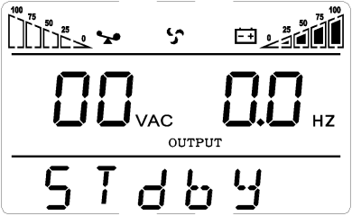 | UPS is powered off and no output supply power, but still can charge batteries.
Battery mode  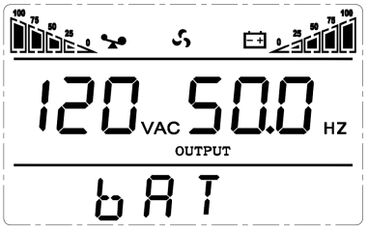 | Being in battery mode are as following: the buzzer beeps once every 4 seconds.  When the mains power is low or unstable, UPS will turn to battery mode at once, and LCD displays ‘batt’.
ECO mode  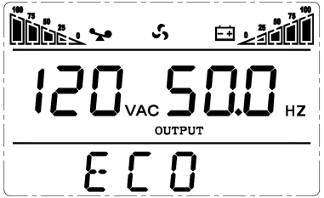 | Being in ECO mode are as following: When the input mains meet the input range of the ECO mode and the ECO function is on, the UPS works in ECO mode. If input mains exceed the range of ECO several times within one minute but stays in inverter input range, UPS will work in inverting mode automatically. LCD displays ‘ECO’.
CUCF mode  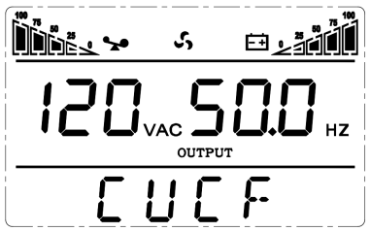 | Frequency conversion mode is mainly to provide a stable voltage and frequency (mainly in terms of frequency). After starting this mode, its output will not be affected by utility to meet input needs of some precision equipment and make users’ load more stable and secure. After opening CUCF mode setup, LCD displays ‘CUCF’. In CUCF mode, the loading capacity will drop to 70% of the original capacity.The output frequency is fixed at the setting value, it doesn’t vary with utility change. And the UPS cannot be set to bypass mode in this mode.
Fault mode  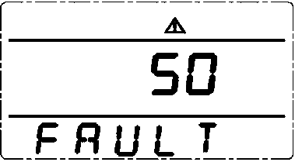 | When UPS has a failure, the buzzer beeps and the UPS turns to fault mode. UPS cuts off the output and LCD displays fault codes. At the moment, users can press the mute key to make the buzzer stop beeping temporarily to wait for maintenance. Users can also press the OFF key to shut down the UPS when confirm that there is no serious fault.

Fault Messages
Table 1: Fault code messages
Fault code | Fault type | Bypass output | Note
0、1、2、3、4 | Bus high | yes
5、6、7、8、9 | Bus low | yes
10、11、12、13、14 | Bus unbalance | yes
15、16、17、18、19 | Bus soft start fail | yes
20、21、22、23、24 | Inverter soft start fail | yes
25、26、27、28、29 | Inverter high | yes
30、31、32、33、34 | Inverter low | yes
35、36、37、38、39 | Bus discharge fail | yes
40、41、42、43、44 | Over heat | yes
45、46、47、48、49 | Output short | no
50、51、52、53、54 | Overload | yes
55、56、57、58、59 | Bus short | yes
60、61、62、63、64 | Shutdown fault | yes
70、71、72、73、74 | Overload 5 times | yes
Table 2: Working status messages
S/N | Working status | LCD display messages |  |  |  | Alarm beep | LCD flashes |  | LED flashes
 |  |  |  |  |  |  |  |  | Inverter | Fault
1 | Inverter mode (mains power)
 | Mains power voltage | Working mode displays Line |  |  |  | No beep | No flash |  | Flash always | /
 | Mains power high/low voltage protection, switch to battery mode | Working mode displays bAT |  |  |  | One beep /4 sec | One flash / 4 sec |  | One flash / sec | /
2 | Battery mode
 | Battery voltage - normal | Working mode displays bAT |  |  |  | One beep / 4 sec | One flash  /4 sec |  | One flash / sec | /
 | Warning for abnormal voltage of battery | Working mode displays bAT, Bat flash |  |  |  | One beep / sec | One flash  /sec |  | One flash / sec | /
3 | Bypass mode
 | Mains power – normal（under Bypass） |  | Working mode displays byPASS |  | One beep / 2 min |  |  | No flash | One flash /2sec |  | /
4 | Warning for battery disconnected
 | Bypass mode |  | Working mode displays byPASS, bat display is 0, and flash all the time |  |  | One beep / 4 sec |  | One flash  / 4 sec | One flash /2 sec |  | /
 | Inverter mode |  | Working mode displays Line, bat display is 0, and flash all the time |  |  | One beep / 4 sec |  | One flash  / 4 sec | Flash always |  | /
 | Power on / Switch on |  | LCD illuminates when power on, and display the capacity of the UPS, later working mode displays Line or byPASS, bat icon flash all the time |  |  | 6 beeps |  | Flash always | Flash always |  | Flash always
 |  |  |  |  |  |  |  |  | / |  | /
5 | Output overload protection
 | Warning for mains power overload |  |  | Working mode displays Line, load icon flash |  | 2 beeps / sec |  | 2 flashes  /sec | Flash always |  | /
 | Protect operation for mains power mode overload |  |  | Working mode displays FAULT and the corresponding codes |  | Long beep |  | Flash always | / |  | Flash always
 | Warning for battery overload |  |  | Working mode displays bAT, load iconflash |  | 2 beeps / sec |  | 2 flashes  /sec | One flash / sec |  | /
 | Protect operation for battery mode overload |  |  | Working mode displays FAULT and the corresponding codes |  | Long beep |  | Flash always | / |  | Flash always
6 | Warning for bypass mode overload |  |  | Working mode displays byPASS, load iconflash all the time |  | One beep / 2 sec |  | One flash  / 2 sec | One flash /2 sec |  | /
7 | Fans fault(fan icon） |  |  | Fan icon flash, working mode displays depending on current mode |  | One beep / 2 sec |  | No flash | / |  | /
8 | Faults mode |  |  | Working mode displays FAULT, numerical value area displays the corresponding error code |  | Long beep |  | Flash always | / |  | Flash always
Note:
- End user need to provide below information when require to maintain the UPS.
- UPS Model No. & Serial No.
- Date of fault occurrence.
- Fault details (LCD status, noise, AC power situation, load capacity, battery capacity configuration ect.)

Table 3: Alarm code display
The alarm code will be displayed in four digital tubes on the right of the numerical part of the LCD screen(red mark), as shown below:
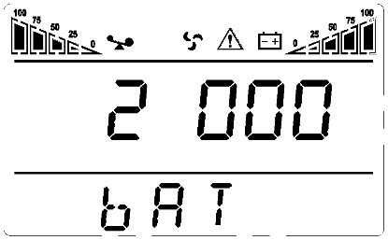
Alarm code
Alarm icon
The alarm truth table during operations is shown as below：
‘●’ signifies the alarm occurs, blank signifies no alarm appears
The first digital tube from right to left | Display value | Bypass lost | Remote Shutdown | Overload | Batterydisconnected
The first digital tube from right to left | 0
The first digital tube from right to left | 1 | ●
The first digital tube from right to left | 2 |  | ●
The first digital tube from right to left | 3 | ● | ●
The first digital tube from right to left | 4 |  |  | ●
The first digital tube from right to left | 5 | ● |  | ●
The first digital tube from right to left | 6 |  | ● | ●
The first digital tube from right to left | 7 | ● | ● | ●
The first digital tube from right to left | 8 |  |  |  | ●
The first digital tube from right to left | 9 | ● |  |  | ●
The first digital tube from right to left | A |  | ● |  | ●
The first digital tube from right to left | B | ● | ● |  | ●
The first digital tube from right to left | C |  |  | ● | ●
The first digital tube from right to left | D | ● |  | ● | ●
The first digital tube from right to left | E |  | ● | ● | ●
The first digital tube from right to left | F | ● | ● | ● | ●
The second digital tube from right to left | Display value | Overcharging warnings | Mains reverse | Start-up abnormal | Charger fault
The second digital tube from right to left | 0
The second digital tube from right to left | 1 | ●
The second digital tube from right to left | 2 |  | ●
The second digital tube from right to left | 3 | ● | ●
The second digital tube from right to left | 4 |  |  | ●
The second digital tube from right to left | 5 | ● |  | ●
The second digital tube from right to left | 6 |  | ● | ●
The second digital tube from right to left | 7 | ● | ● | ●
The second digital tube from right to left | 8 |  |  |  | ●
The second digital tube from right to left | 9 | ● |  |  | ●
The second digital tube from right to left | A |  | ● |  | ●
The second digital tube from right to left | B | ● | ● |  | ●
The second digital tube from right to left | C |  |  | ● | ●
The second digital tube from right to left | D | ● |  | ● | ●
The second digital tube from right to left | E |  | ● | ● | ●
The second digital tube from right to left | F | ● | ● | ● | ●
The third digital tube from right to left | Display value | EEPROM abnormal | Fan abnormal | Low battery | Median abnormal
The third digital tube from right to left | 0
The third digital tube from right to left | 1 | ●
The third digital tube from right to left | 2
The third digital tube from right to left | 3 | ●
The third digital tube from right to left | 4 |  |  | ●
The third digital tube from right to left | 5 | ● |  | ●
The third digital tube from right to left | 6 |  |  | ●
The third digital tube from right to left | 7 | ● |  | ●
The third digital tube from right to left | 8 |  |  |  | ●
The third digital tube from right to left | 9 | ● |  |  | ●
The third digital tube from right to left | A |  |  |  | ●
The third digital tube from right to left | B | ● |  |  | ●
The third digital tube from right to left | C |  |  | ● | ●
The third digital tube from right to left | D | ● |  | ● | ●
The third digital tube from right to left | E |  |  | ● | ●
The third digital tube from right to left | F | ● |  | ● | ●
The fourth digital tube from right to left | Display value | Over load fault | Mains lost | Bypass abnormal
The fourth digital tube from right to left | 0
The fourth digital tube from right to left | 1 | ●
The fourth digital tube from right to left | 2 |  | ●
The fourth digital tube from right to left | 3 | ● | ●
The fourth digital tube from right to left | 4 |  |  | ●
The fourth digital tube from right to left | 5 | ● |  | ●
The fourth digital tube from right to left | 6 |  | ● | ●
The fourth digital tube from right to left | 7 | ● | ● | ●
Example:
If the alarm code "2000" appears on the LCD screen, it indicates loss of mains power.

Troubleshooting
When the system works in fault mode, the LCD displays as below:
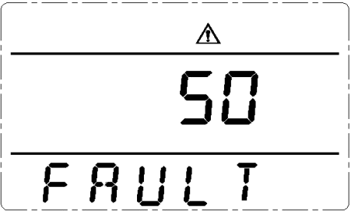

F Fault icon

Fault code

Problem | Possible Cause | Solution
Fault icon display, audible buzzer alarm continually, the fault code is 00-14 | Bus voltage fault | Test the bus bar voltage or contact the supplier.
Fault icon display, audible buzzer alarm continually, the fault code is15-24 | Soft start fault | Check the soft start circuit, especially the input fuse or contact the supplier directly.
Fault icon display, audible buzzer alarm continually, the fault code is 25-39 | Inverter voltage fault | Contact the supplier.
Fault icon display, audible buzzer alarm continually, the fault code is 40-44 | Over heat | Be sure that the UPS arenot overloaded, and the fan vent is not obstructed, as well as the indoor temperature is not high.  Leave alone the UPS 10 minutes for cooling, and restart it. If the problempersists, contact the supplier.
Fault icon display, audible buzzer alarm continually, the fault code is 45-49 | Output short | Turn off the UPS and disconnect all the loads.Be sure there is no any fault or internal short circuit of the loads.  And then restart the UPS. If the problempersists, contact the supplier.
Fault icon display, audible buzzer alarm continually, the fault code is 50-54 | Overload | Check the load level and disconnect the non-critical equipments, recount the total capacity of your load and reduce the load to the UPS.  Check whether the load equipments has fault or not.
Fault icon display, audible buzzer alarm continually, the fault code is 55-59 | Bus short | Contact the supplier.
Fault icon display, audible buzzer alarm continually, the fault code is 60-64 | Shutdown fault | Check the first button of the LCD panel is pressed and cannot be bounced
Fault icon display, audible buzzer alarm continually, fan icon in the LCD flickers | Fan fault | Check whether the fans are connected and fixed well or not, and if fansare not broken. If all seems fine, contact the supplier.
UPS fail to start when operate ‘On’ key | Pressing time too short | Press the power key more than 2 seconds to start the UPS.
UPS fail to start when operate ‘On’ key | The input connection is not ready or  UPS internal battery disconnect | Connect the input well, if the battery voltage is too low, disconnect the input and start the UPS with no-load.
UPS fail to start when operate ‘On’ key | UPS internal system fault | Contact the supplier.
Back up time become short | Battery undercharge | Keep the UPS battery recharging more than 3 hours
Back up time become short | UPS overload | Check the load level and disconnect the non-critical equipments,
Back up time become short | Battery maturing, capacity descend | Replace with new batteries, contact the supplier to get the new batteries and spare parts.
UPS doesn’t have any power going through even mains power on | UPS input breaker disconnected | Reset the circuit breaker by manual.

Note:
When the output is short-circuited, the action of UPS protection will show up. Before turning off the UPS, make sure to disconnect the entire loads and cut off the mains power supply, otherwise it will make the AC input shortcircuit.

Software Download & Installation
（Only for the model with communication port）

Please follow steps below to download and install monitoring software :
1 . Go to the website https://www.idbkmonitor.com
2 . Click UPSSmartView software icon and then choose your required OS to download the software
3 . Follow the on-screen instructions to install the software

